OMAP1510 - Availability Disclaimer
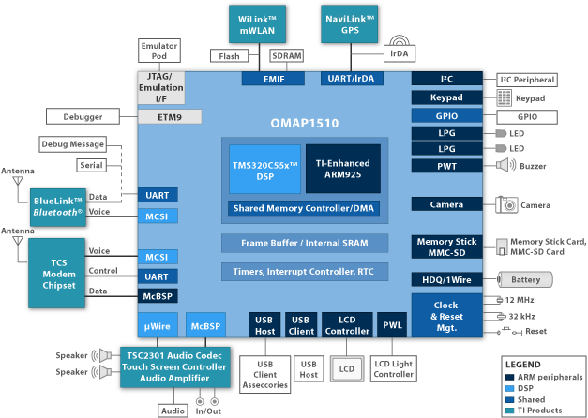
The OMAP1510 dual-core application processor enables 2.5G and 3G wireless handsets and PDAs to run applications such as streaming video, audio, mobile commerce, location-based services and others. It is intended for high-volume wireless OEMs and ODMs and is not available through distributors.
To provide the optimal balance of high performance and low power consumption necessary for these devices, the OMAP1510 combines the TMS320C55x™ DSP core with a TI-enhanced ARM925 processor.
The ARM architecture is well suited for control-type code such as the OS and user interface. The C55x™ DSP provides the additional processing power to handle the compute-intensive operations such as security, multimedia, and speech.

OMAP1510 Processor Features:
Low-Power, High-Performance CMOS Technology
- Low-voltage 130 nm technology
TMS320C55x DSP Core
- Up to 192 MHz (maximum frequency)
Voltage: 1.5v nominal
- One/two instructions executed per cycle
- 32K x 16-bit on-chip dual-access RAM (DARAM) (64 KB)
- 48K x 16-bit on-chip single-access RAM (SARAM) (96 KB)
- 16 KB I-cache, 8 KB D-cache
- Video hardware accelerators for DCT, iDCT, pixel interpolation, and motion estimation for video compression
TI925T ARM9TDMI Core
- Up to 168 MHz (maximum frequency)
Voltage: 1.5v nominal
- 16KB I-cache; 8KB D-cache
- 192-KB of shared internal SRAM - frame buffer
- Support for 32-bit and 16-bit (Thumb mode) instruction sets
- Data and program MMUs
- Two 64-entry translation look-aside buffers (TLBs) for MMUs
- 17-word write buffer
Memory Traffic Controller (TC)
- 16-bit EMIFS external memory interface
- 16-bit EMIFF external memory interface
9-Channel System DMA Controller
Digital Phase-Locked Loop (DPLL) for MPU/DSP/TC Clocking Control
Comprehensive Power-Saving Modes for MPU/DSP/TC
IEEE Standard 1149.1 (JTAG) Boundary Scan Logic
Application Subsystem
- Supports leading operating systems
- Three 32-bit timers and watchdog timer
- 32-kHz timer
- Level1/Level2 interrupt handlers
- USB1.1 host interface with up to 3 ports
- USB1.1 function interface
- One integrated USB transceiver for either host or function
- Multichannel buffered serial port (McBSP)
- I²C master and slave interface
- Micro-wure serial interface
- MMC/SD interface
- HDQ/1-wire interface
- Camera interface for CMOS sensors
- ETM9 trace module for TI925T debug
- Keyboard matrix interface (6 x 5 or 8 x 8)
- Up to 10 MPU general-purpose I/Os
- Pulse-width tone (PWT) interface
- Pulse-width light (PWL) interface
- Two LED pulse generators
- Real-time clock
- LCD controller with dedicated system DMA channel
- Two multichannel buffered serial ports
- Two multichannel serial interfaces
- Three UARTs (one supporting SIR mode for IrDA)
- Four interprocessor mailboxes
- Up to 14 shared general-purpose I/Os
289-ball, 12 mm x 12 mm MicroStar™ BGA Package
OAK DSP

CEVA-X1641™ | Quad MAC 16-bit fixed point DSP  Combination of VLIW and SIMD architecture concepts  Up to 8 instructions issued simultaneously  Variable instruction width (16/32-bit) and variable length of instruction packets  Two level memory architecture  Up to 4G byte addressable memory space  64K/96K/160K byte L1 program memory and cache  64K/128K byte L1 data memory  Program and data DMAs  Nine stage pipeline  All instructions can be conditionally executed  Four 16x16-bit MAC units  40-bit Shift unit  40-bit Logical unit.
CEVA-X1622 | Dual MAC 16-bit fixed point DSP  Combination of VLIW and SIMD architecture concepts  Up to 8 instructions issued simultaneously  Variable instruction width (16/32-bit) and variable length of instruction packets  Two level memory architecture  Up to 4G byte addressable memory space  64K byte L1 program memory and cache  64K/128K byte L1 data memory  Program and data DMAs  Nine stage pipeline  All instructions can be conditionally executed  Two 16x16-bit MAC units,  40-bit Shift unit  40-bit Logical unit.
CEVA-X1620 | Dual MAC 16-bit fixed point DSP  Combination of VLIW and SIMD architecture  Up to 8 instructions issued simultaneously  Variable instruction width (16/32-bit) and variable length of instruction packets  Two level memory architecture  Up to 4G byte addressable memory space  64K byte L1 program memory and cache  64K byte L1 data memory  Program and data DMAs  Nine stage pipeline  All instructions can be conditionally executed
CEVA-Teak | Soft core (process- and library-independent).  Low-voltage operation, down to 1 Volt  Low power consumption. Three power modes:  Active mode  Slow mode - linearly reduces clock speeds and current consumption by a user defined factor  Stop mode - leakage current only
CEVA-TeakLite-II | High frequency – up to 200 MHz @ 0.13u worst case process  Low power consumption  Active mode - using full DSP capability  Slow mode - clock speed and current consumption, linearly divided, relative to active mode by a user-defined factor  Stop mode - leakage current only  High code density using 16-bit instructions width
CEVA-TeakLite | Fully Static Design. Cool CEVA-TeakLite version - optimized for very low power consumption.

